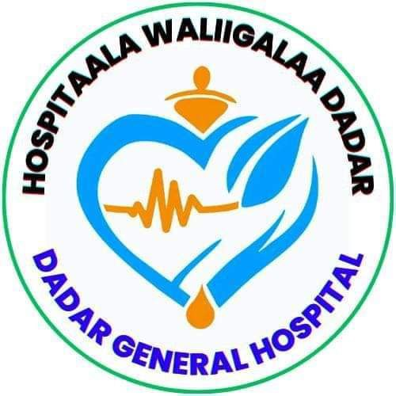

Deder General Hospital Healthcare-Associated Infection (HAI) Surveillance Logbook

2017/2017

Deder General Hospital Healthcare-Associated Infection (HAI) Surveillance Logbook
Case team name ______________________________
Date | Patient ID | Type of Infection (BSI, CAUTI, SSI, VAP, etc.) | Diagnosis Criteria Met? (Yes/No) | Treatment Initiated | Outcome | Remarks

Deder General Hospital Healthcare-Associated Infection (HAI) Surveillance Logbook
Case team name ______________________________
Date | Patient ID | Type of Infection (BSI, CAUTI, SSI, VAP, etc.) | Diagnosis Criteria Met? (Yes/No) | Treatment Initiated | Outcome | Remarks

